**Nexus 7 can’t be recognized by MS-Windows via USB**

1.Connect your Nexus 7 to your computer's USB port.

2.Right-click on Computer from your desktop or Windows Explorer, and select [Manage].

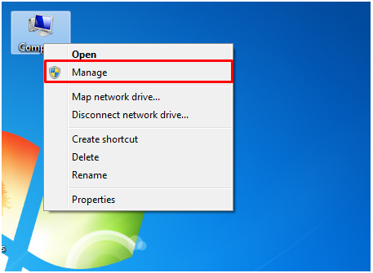

3.Select [Device Manager] in the left pane of the Computer Management window.

4.Locate and expand [ASUS Android Device] in the right pane.

5.Right-click Android Composite ADB Interface and select [Update Driver Software].

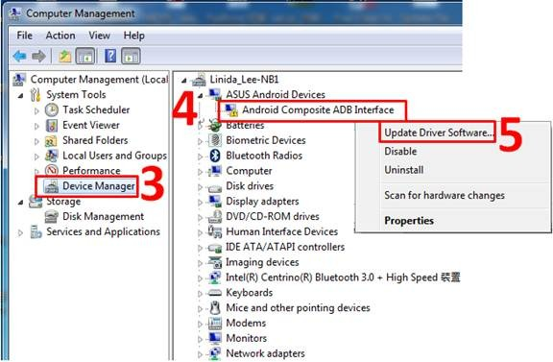

6.Click [Browse my computer for driver software] to specify a location.

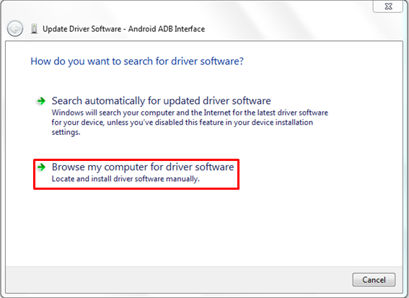

NOTE : Some time it’s located in Other devices. We have to right click & process follg steps.

7.Click[Let me pick from a list of device drivers on my computer to specify the driver file.

NOTE :

First we have to downlaod USB Driver from **http://dottech.org/26188/usb-adb-and-fastboot-drivers-for-windows-for-all-android-phones/#all**

**Or Nexuz product here Asus. So, I get driver from asus site.**

( i.e )relavent Nexux 7 or category. I will enhance this for my blog too. Thanks for your feture post.

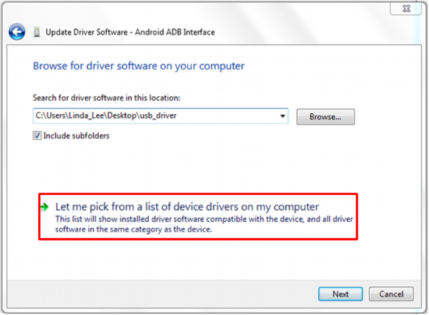

8.Click [USB Composite Device] option and Click on [Next].

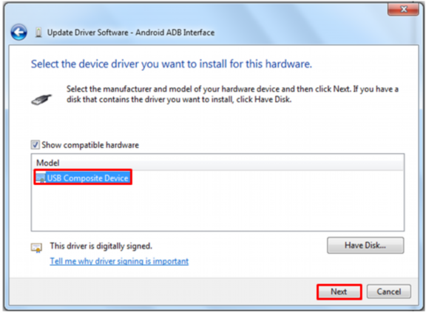

9.Click [Close] when the update is finished.

